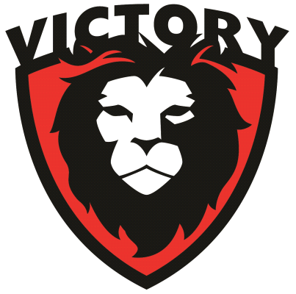

For: Clothing INC at the Strickler Center- 1114 W. High St. - Mt. Pleasant MI.

To: Any and all who are looking to join in the effective distributions of clothing to those who are in need without personal resources to purchase.

We are Victory Christian Center and currently the “owners / lessors” of the facility / property owners now called The Strickler Center. We entered a lease with United Way with the full understanding of several sub-lessee’s coming into the building, with directions and approvals of use / renovations of spaces from United Way and Victory. We Have seen Clothing INC as one of these sub-lessee’s - use, renovate, and expand their great and needed work. They have set up and run the distributions of clothing to those in need with efficiency and care. This efficiency and care are not only with the financial and clothing resources they have, but also shown unto all the people they interact with. We have seen firsthand the staff and volunteers of Clothing INC with dedications behind the scenes in the receiving, sorting, and displaying of clothing donations. Also, many times of witnessing their great care, concerns, and compassion as they come alongside the recipients in the processes of distribution.
Their process looks, feels, and gives the sense of a “store” this model shows the respect to those receiving.

When the day comes that the facility / property is purchased fully from Victory, we will continually look for ways (financial, and hands on) to come along side of Clothing INC (and others) at the Strickler Center. We find that if specifically called, experienced, and gifted people join with singular vision, purpose, and defined goals……. they can achieve in ways that exceed their financial resources. Clothing INC is an example of this. It would be a blessing to see them expand into the spaces and places fulfilling all that our Lord has directed and called them to.

Pastoral Staff
Victory Christian Center
2445 S. Lincoln Rd.
Mt. Pleasant Mi.

Office 989-772-3909

